

**WEEK - 5**

**Computer & Networks**

**M. Sumanth Reddy**

**1. Simulation configuration of DNS, FTP, web, email server to measure the transport layer protocol using CISCO packet tracer**

**Intro:**

In this network we used to perform various operations like DNS, FTP, web browser and server usage, and to establish the communication between them.

We will build this network using:

4 Pc’s

1 Server

1 Switch is present to connect all of them each other.

**DNS: -** Domain Name System

**FTP**: - File Transfer Protocol

**Apparatus:**

In this network we have used:

**Switch:** The Switch is used to Connect between two devices and here we have used **2960-24TT** and it consists of 24 ports which means we can connect 24 devices for single Switch which is widely used in Lab, Industrial Purposes.

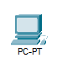**Pc:** The Pc is an end device, used as receiver and sender of Packets in this network and by transferring the packets from one Pc to another Pc we can declare working status of the Network.

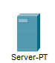**Server:** Server is a device which works as a middle end device for Internet and end devices, and it handles the working progress for different devices.

**Twisted Straight Wire:** Used to Connect the different devices in the Network

**Construction of the network:**

In this network we will divide each Pc into separate clients as different protocols.

PC0 as **Web** client

PC1 as **DNS** client

PC2 as **Email** Client

PC3 as **FTP** client

Server0 as **Server**

**Configure:**

Now we will assign IP address for each of the device

To configure the IP addresses click on the pc and now select desktop on the top and click on it, and we can see IP configuration option by selecting it we can see IPV4 address slot and enter the IP address which was given below for each pc and below that there is DNS server in that enter the 10.10.10.5

PC0 – 10.10.10.1

PC1 – 10.10.10.2

PC2 – 10.10.10.3

PC3 – 10.10.10.4

Server0 – 10.10.10.5

And enter the DNS server address as **10.10.10.5** for every device in the network.

Connect each device with switch using **straight-forward-cable** because we are connecting with different device.

**Procedure:**

Now after declaring the IP addresses and connecting the devices to the switch.

**DNS Client:**

Firstly, we must declare a DNS client so then open the Server select the services and now click on the DNS which was on the left.

And then there was a few empty slots and there was a name slot now enter the **[www.google.com](http://www.google.com)** in it and below that there was an address option, now enter the DNS address [10.10.10.5] in that slot and finally click on the **add** option it will add

Make sure to **ON** the DNS Service before entering the address above.

Now to check whether the above process is working or not open the DNS client, go to the desktop, click on the command prompt, and enter the **nslookup [www.google.com](http://www.google.com)** if it is correct, it will display the 10.10.10.5 or it will show an error.

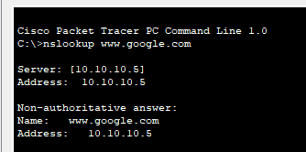

**HTTP:**

Now after finishing the DNS click on the services in the server and select the HTTP in the services and there we can see lots of html files which was already written by default, and delete them all and click on the new file and enter some data using attributes **<html> ….data....</html>** and save the file using **.html** extension.

After finishing the HTML file, open the desktop in the DNS client click on the Web browser enter the **URL** as [www.google.com](http://www.google.com) and hit the run button, we can see the data that was written in html file.

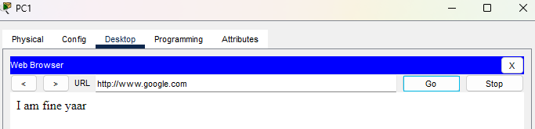

**Web client && Email client:**

**Web client:**

In this we will establish a connection between the web client and Email client to communicate between them using mails.

First, we will do with web client so then the Web client Pc and click on the desktop and select the **Email**

And there we can see many of the empty slots

**User Information**

Name: sumanth

Email address: [sumanth@gmail.com](mailto:sumanth@gmail.com)

**Server Information**

Incoming mail server: 10.10.10.5

Outgoing mail server: 10.10.10.5

**Logon Information**

Username: sumanth

Password: 1234

And save the details

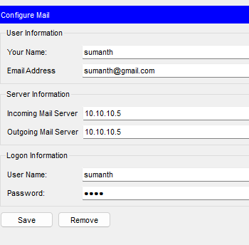

**Email client:**

Same as above web client now apply same process to email client also

**User Information**

Name: babbu

Email address: babbu[@gmail.com](mailto:sumanth@gmail.com)

**Server Information**

Incoming mail server: 10.10.10.5

Outgoing mail server: 10.10.10.5

**Logon Information**

Username: babbu

Password: 1234

And save the details

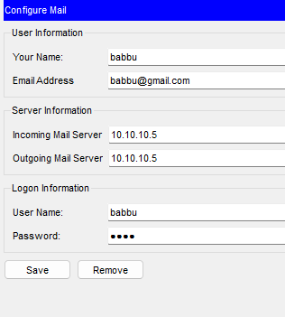

After setting up the both the Web & Email client now go the server and select the services and click on Email and Switch ON the SMTP and POP3 and enter details as

Domain name: gmail.com

User1: sumanth

Password: 1234

User2: babbu

Password: 1234

To add more users, we can use **+** symbol which was at right below.

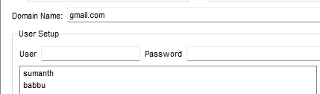

Now open the Web client and go to mail and select compose and type Email client’s email address and type some matter and send it.

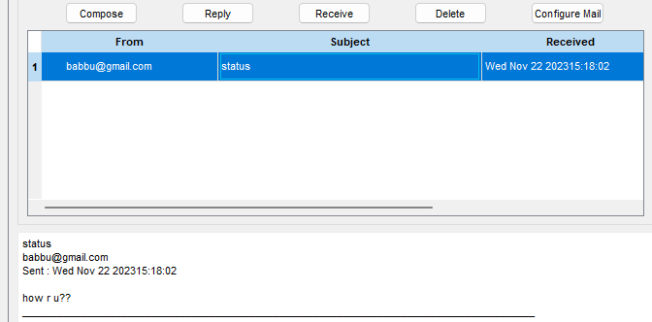

Now go to Email client go to Email option and check in the receive there you can see the mail send by the Web Client.

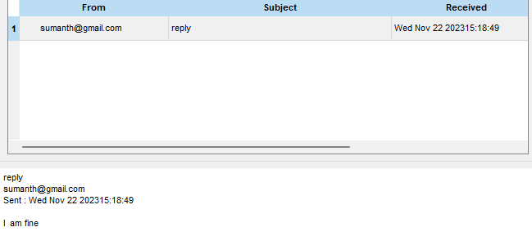

**FTP:**

Now we will do the FTP, to do the ftp open the server and select the FTP option and there we have User setup and enter the details in it as

Username: admin

Password: 1234

After that select all the READ, WRITE, DELETE, LIST, RENAME and add it.

Now open the FTP client and select the desktop and click on the text editor and enter some data and save that text file.

After that open the command prompt in the FTP client and enter

//ftp [www.google.com](http://www.google.com)

//Username: admin

//Password: 1234

//ftp: put tx1.txt

//dir [detail info about file]

It will display file was transferred.

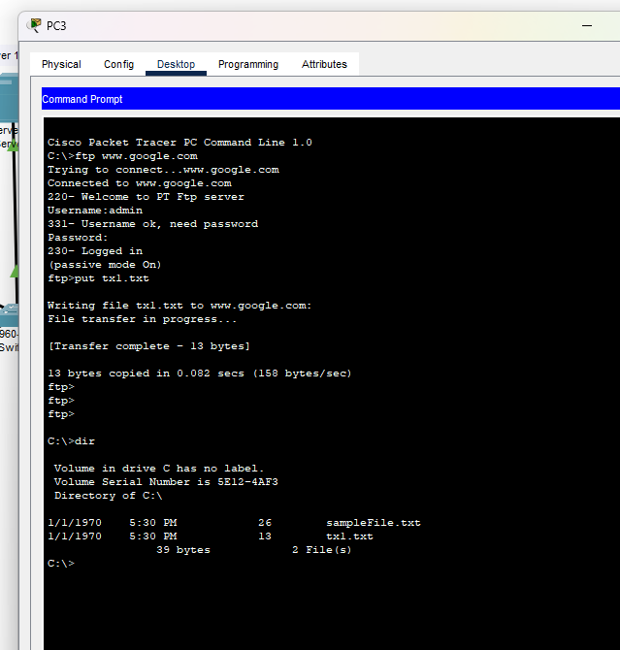

Then open the DNS client to make sure that the file received or not.

Open the desktop in DNS and select command prompt and type:

//ftp [www.google.com](http://www.google.com)

//Username: admin

//Password: 1234

//ftp: get tx1.txt

//dir [detail info about file]

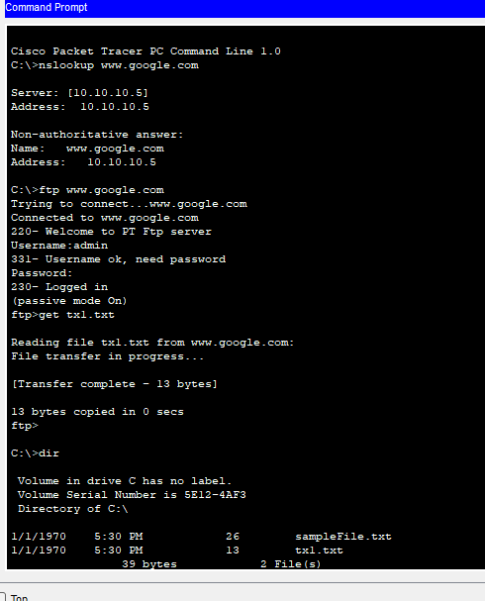

And we can check the file in the **DNS Client > Desktop > TGTP Service**, and there we can see that tx1 file has arrived.

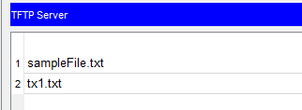

**Arrangement of Network:**

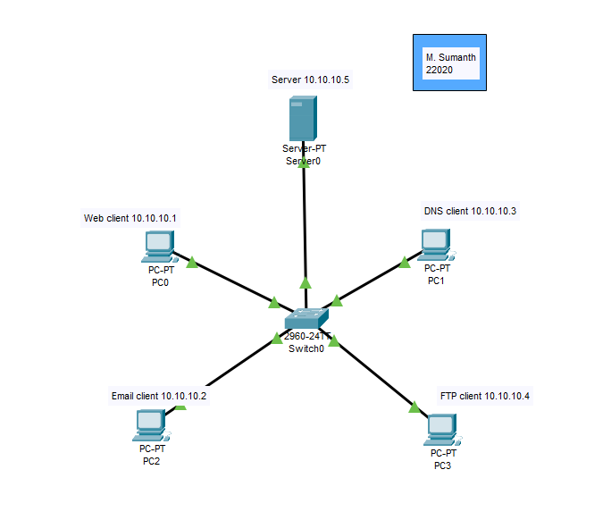

**After Running Packets:**

By transferring the packets, we can know that much about the Network and how it works and there is an any problem any connection and we can rectify it. In below we had assigned the packets for two different Pc’s and the travelling packets, and the switch will send the different packets for every Pc with the unique receiver ID the Pc will respond and it will resend back the packet to the sender, and it will be successful.

**OUTPUT:**

**Realtime mode:**

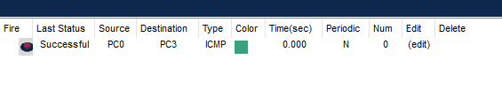

**Simulation mode:**

If provides the detailed information about the packet from which it travels from one switch to another switch and provides the detailed info about time taken from switch to switch and packet which is at present device.

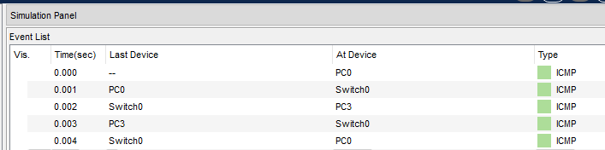

**Successful case:**



**Failed Case:**

In this network I tried to send the packets from PC1 to PC3, there may be arrive many failed cases as:

* When power off between sender and receiver
* Given different default address
* Does not having IP addresses on a series line

And many more...

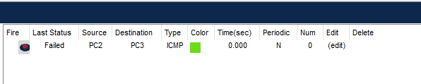

**PING:**

By using Ping, we can check the connection from the one pc to another pc by using IP address and it display the time taken to connect and show no of packets have been transferred, received and lost while transferring.

In Some cases, due to some network issues the packets which was will be lost.

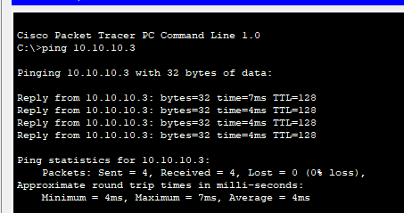

**PROS:**

* **Hands-On Learning:** Simulation environments provide a practical, hands-on learning experience without the need for physical hardware. This is especially beneficial for those who are learning about networking and server configurations.
* **Protocol Understanding:** *Pro:* By configuring DNS, FTP, web, and email servers, you gain a deeper understanding of how these protocols work at the transport layer. This can enhance your knowledge of network protocols and their interactions.

**CONS:**

* **Limited Real-World Experience:** While simulations provide a good learning environment, they may not fully replicate the challenges and intricacies of a real-world network. Real-world scenarios may involve factors that are challenging to simulate accurately.
* **Resource Limitations:** Simulations are limited by the resources available in the simulation environment. In a real-world scenario, factors like bandwidth, latency, and hardware limitations can significantly affect the behaviour of network protocols.

**Simulation mode in IPV4:**

After removing the connections in the IPV4 and go to any PC and check the

**nslookup [www.google.com](http://www.google.com)** and it will not execute.

So then come to the simulation mode and run the pause and do fast-forward button and then running the packets it will execute in the command prompt.

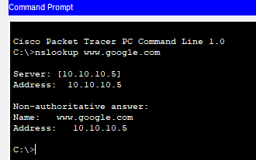

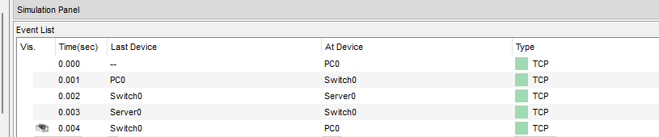

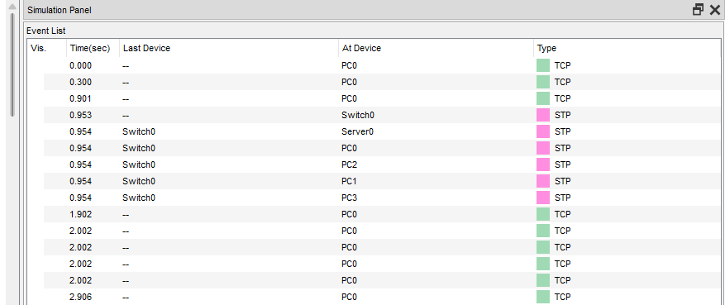

**CONCLUSION:**

We can conclude that in this network we have used the FTP, HTTP, Email, and DNS in a single network. It made us learn about the individual studying of different network layers and the greater number of protocols in a small network which may help in cost-effectiveness and time efficiency in packet tracer.